



Blackboard Transact Mobile eAccounts Application

for iPhone / iPod Touch / iPad ( iOS 5 or later )

Install Guide

Contents

1.INSTALLING eACCOUNTS APP

2.SEARCHING FOR SOUTH DAKOTA STATE UNIVERSITY

3.LOGGING INTO THE eACCOUNTS PORTAL

4.HOME SCREEN

**1. INSTALLING eACCOUNTS APP**

To install the eAccounts mobile application on your Apple iPhoneTM or iPod TouchTM or iPadTM, open App Store and search for "Blackboard Transact Mobile eAccounts". Install the application on your device by clicking on install button in the App Store.

Figure 1.1

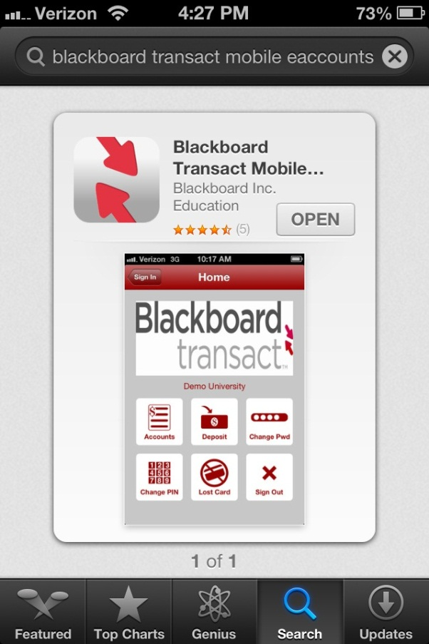

**2. SEARCHING FOR SOUTH DAKOTA STATE UNIVERSITY**

After installing Blackboard (Bb) Transact to your Apple iPhoneTM or iPod TouchTM or iPadTM device, tap the eAccounts icon to open the application. Select South Dakota State University from the initial screen; by scrolling through the list or entering "South Dakota State University" in search value to find the school. After selecting the South Dakota State University Site, click on SDSU Login. Now the South Dakota State University eAccounts selection is configured in your device. A sample search screen is shown below.

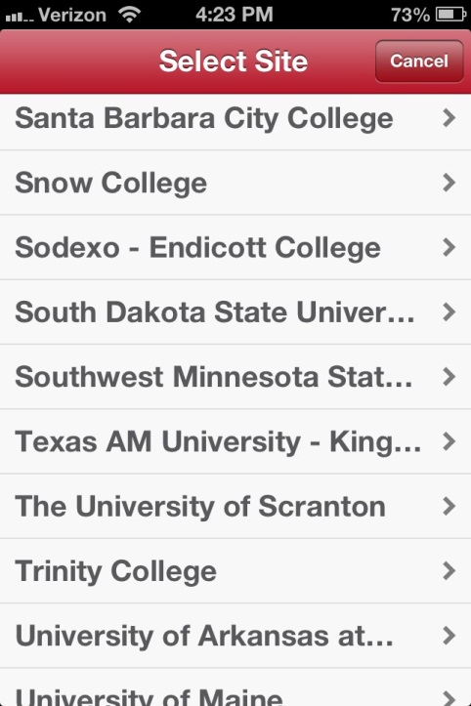 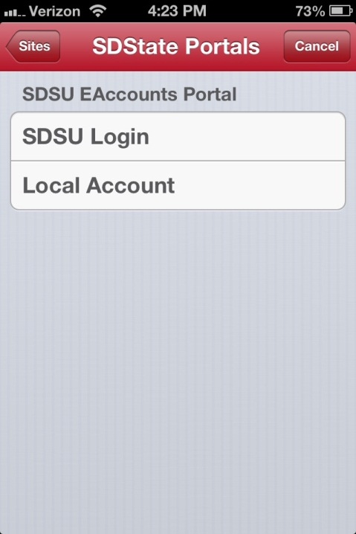

Fig 2.1 Select site and select SDSU Login.

**3. LOGGING INTO THE EACCOUNTS PORTAL**

Click on the South Dakota State in the Sites page. (See screenshot below) Following the selection of the login method, a screen displays for sign-in as shown below. On subsequent uses of the application, the login screen automatically displays. Enter your South Dakota State University Username and Password exactly as you would when using the eAccounts web page and hit GO.

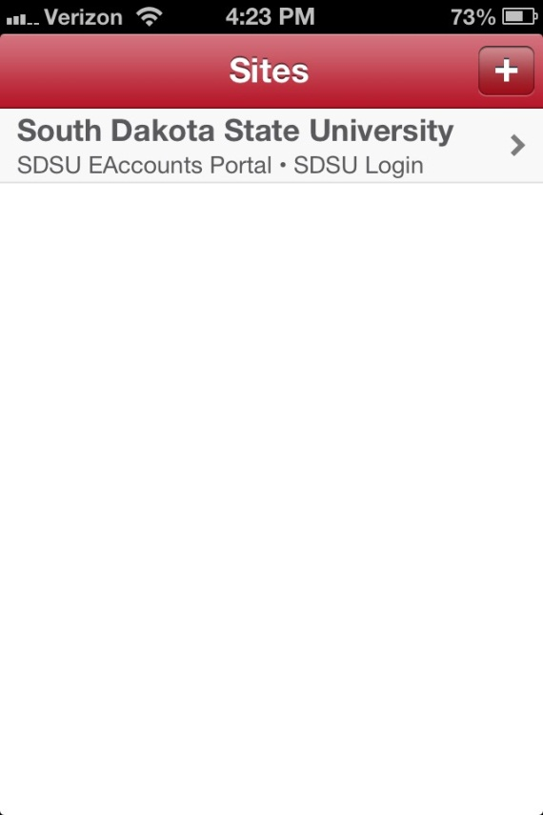 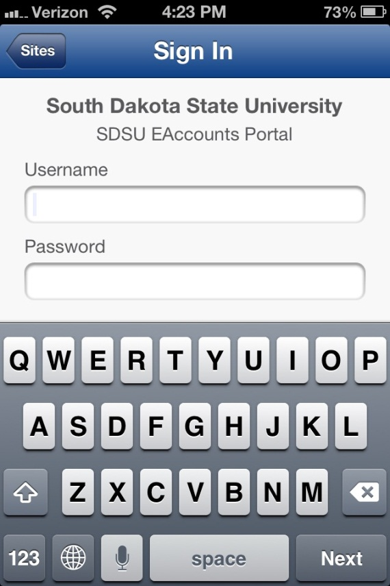

Figure 3.1 Sign on Screen

**4. HOME MENU**

The Home screen displays all the current available features in the application. A sample Home menu screen is shown below.

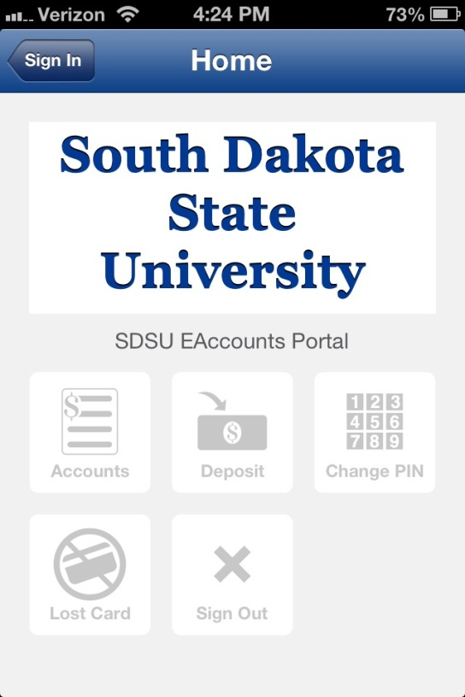

Figure 4.1 Home Screen